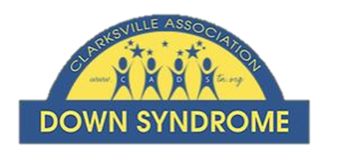

CADS Technology for Teachers
Statement of Attestation

The Clarksville Association Down Syndrome (CADS) Technology for Teachers Grant Competition will fund two $3,000.00 projects and up to six $500.00 projects. As part of the application process, attestations are being requested to ensure that there is endorsement from leadership at the applicant’s school.

I understand the purpose of the Technology for Teacher’s Grant competition;
I understand the project being submitted by the applicant;
I attest the applicant, the special education teacher, has the knowledge and skills to carry out this project, and I attest the project is appropriate for the school special education program. I understand grant award money must be spent on the proposed project as outlined in the application proposal.

I support the grant application of _____________________________________, and agree to the special education teacher’s participation in the grant competition, and carrying out the project if awarded.

Print Name Title
Signature Date

